ECE/CS 250: A Guide to Debugging Logisim

# Common issues:

* **If many wires/buses turn blue unexplainably, restart Logisim.**
* The input and output pins should be labelled exactly as required. E.g. "out" and "Out" are not the same. Make sure there are no extra spaces in labels as well.
* Output pins must be output pins and not input pins, and vice versa.
* If you use subcircuits and you put your top-level circuit in some other subcircuit: Right-click > Set as main circuit.
* If you see circles/dots on your ports (like in the picture below), that means you accidentally connected two ports of a unit to each other. This can easily happen because things are tiny and most of us are using trackpads and not mice. To fix it, delete the entire neighborhood that includes that mess and rebuild that part.  
  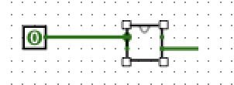

In the image above, it looks like only one pin is connected on either side of the box, but both the pins on the left are connected to the 0-input pin. Only one pin (of the two) on the right-side box is connected. The large circle is what tells you that something’s wrong. When fixed, it should look like the following circuit:

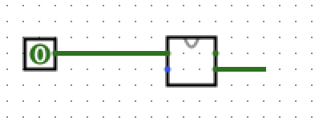

* You shouldn't use multiple clocks in a circuit. Even different subcircuits shouldn't have different clocks. Your main circuit should have a clock, and every clocked component in all your circuits/subcircuits should use the same clock to be in sync.
* You can use the constant component if you need a constant value.
* Make sure wires aren’t accidentally connected to each other.
* For sequential circuits, make sure you’ve configured components to be triggered on the edges as prescribed by the HW documents. All clocked components have a Logisim property to decide whether it will be rising-edge triggered or falling-edge triggered. Avoid “not-ing” a clock signal because this can cause unintended issues. Use the build in trigger-settings where possible.
* **If you have taken care of all these commons mistakes and bugs still persist, you need to debug your circuits by running them one clock tick at a time (this is analogous to stepping through programs line-by-line).**

As you’re clicking through your program one clock tick at a time, carefully note the changes that are taking place in all the components of your circuit. Any time that you see an unexplained change in a component’s or wire’s contents (or a wire goes red for some reason), you know exactly what clock cycle caused the issue. Try to think about what happened in that clock cycle that might’ve been problematic.